**“Lime Rancher”**

**GAME DESIGN DOCUMENT**

**For Pirate Software - Game Jam 14**

Team Info/Credits

The Magma Psychic - Programming

HeartBox1/Max Cheskin - Programming

jxner- Art

Ms.Okami - Art

Scratchy - Sound Design/Music

Software and tools

Game engine - Godot

Version control - Github

Art software - Aesprite

Audio software - Reaper, Phaseplant, Super Audio Cart

Introduction

**Game Summary**

Lime Rancher is a tower defense game with a timer-based night-day system. During the day, the player controls a small character and must set up towers and plant limes for the night phase, where enemies will walk toward a shrine at the top of the map. If the player can survive for 4 days without the shrine being destroyed, the game ends.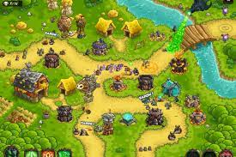

Inspiration

**Kingdom Rush:**

Kingdom rush uses a **limited-time mechanic** to some similar effect which forces the player to think on their feet and make uncertain, heat-of-the moment decisions. It leads to a faster, smoother tower defence experience which is much less about min-maxing and more about adapting to situations as they arise.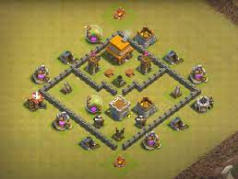

**Clash of Clans:**

Clash of Clans is unique among tower defenses as that combat takes place over an **open field**, allowing the defender to better control the objectives and pathfinding of the attackers. It also does away with set slots for buildings, and instead **its players can** **build anywhere**. This widens the decision space considerably.

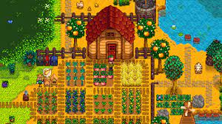

**Stardew Valley:**

A well-known farming game that uses a **day-night system** that’s loosely attached to a timer in order to track the growth of crops. If a crop is planted on Day 1 of Spring, it can be set to ripen on Day 5 thereof. This makes crop growth uniform and predictable across the field, and keeps the players’ plans simple.

Slime Rancher: While discussing Slime Rancher as an example of farming mechanics, one of the team members misspoke in such a way that it sounded like they said lime rancher. The entire premise of the game was decided on the spot.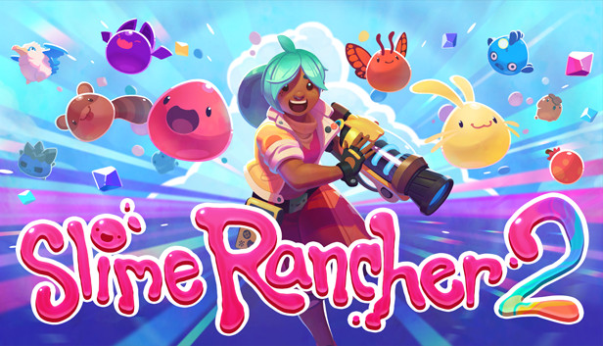

**Platform**

This game is going to be controlled entirely through a keyboard. Controller options will be made available later. The game is to be played exclusively on a Windows PC.

**Target Audience**

This game contains very simple, smoothed-out tower defense mechanics, and is suitable for casual players who are at least familiar with tower defense games as a concept.

Concept

**Gameplay Overview**

Lime Rancher is a tower defense game **with night and day phases** and an **isometric top-down protagonist**. During the day, the player controls a small character and must set up towers and plant limes on an **open, square field** for the night phase, where enemies will amble toward either a shrine at the top-center of the map or the plants that the player planted. The player must defend **both the shrine at the top of the map** and **the lime plants that they plant.** If the shrine lasts for 4 days without being destroyed, the player wins. Lime plants will supply limes, the primary currency in the game, the day after they’re planted.

**Theme Interpretation**

The player’s reach and area of influence is growing over time. Newspapers will pop up to divide the days and contain headlines about how limes are, in one way or another **spreading** over the world. This is in the form of global lime obsession, transformations of objects into limes, and the proliferation of limes from non-lime-related plants. In addition, the final cutscene involves the moon turning into a lime.

**Primary Mechanics (day phase)**

There are two primary resources in Lime Rancher; Limes, which are used to make turrets, and seeds, which are used to plant lime plants, which will grant a lime the next day, provided they survive the night. The player will have a very strictly limited amount of time to set up their defenses for the night. Each action will involve an overlong animation, meaning that the player will have to budget time as well.

**The player’s actions will be as follows:**

* Planting a lime plant. The player spends a seed to create a lime plant.
* Planting a turret. The player spends some amount of limes to create a turret.
* Harvesting a plant. The player selects an existing plant that is 1 or 2 days old. If it is “ripe”, meaning that it has survived one day, it will supply 1 lime. If it is “Mature”, meaning it has survived two days, it will supply 3 limes. Either way, the player also gets a seed.
* Uprooting a plant. The player will select an unripe plant and uproot it, which returns the seed.

**Primary Mechanics (Night Phase):**

During the night phase, the player is absent and must watch as the turrets defend their lime ranch. Enemies such as townsfolk with torches and pitchforks will approach the ranch from left, right, and bottom. By default they walk directly towards the nearest target (either shrine or lime plant) and attack them. If they get close enough to their target, they will start draining its health. If the shrine is overrun and demolished, the player is sent to the start of the game. Once all enemies are dead, the night ends and transitions into the next day.

ART

**Inspirations:** 

**Elements**: Main character and the enemies - They were inspired by Fez, as they were a very simple design it was easy to animate them and keep them consistent with other sprites.

**Turrets** - To deviate it from just being a plants vs zombies plant it uses a gun instead, it has legs and arms to reinforce the theme of supernatural limes.  
**Altar** - It has an added symbol on it that’s never explained but to make the player wonder. The altar is the only more “serious” element in the game in order for it to play into the ending sequence of the game.

**Lime plants** - They differ from actual lime plants as those would be hard to recreate. The limes have eyes to highlight the “supernatural” part of them. Also, grown and mature limes have an outline around them to make them stand out more for gathering.

**Newspaper** - How the newspaper looks was inspired by Papers, please but, the idea came before that and was chosen because it fit the style of the game.

**Newspaper** (mechanic) - It exists to give the player more context about the game world and help reinforce the theme of the game in an non intrusive and more subtle way that fits the style.

Sound Design/Music

**Inspirations:**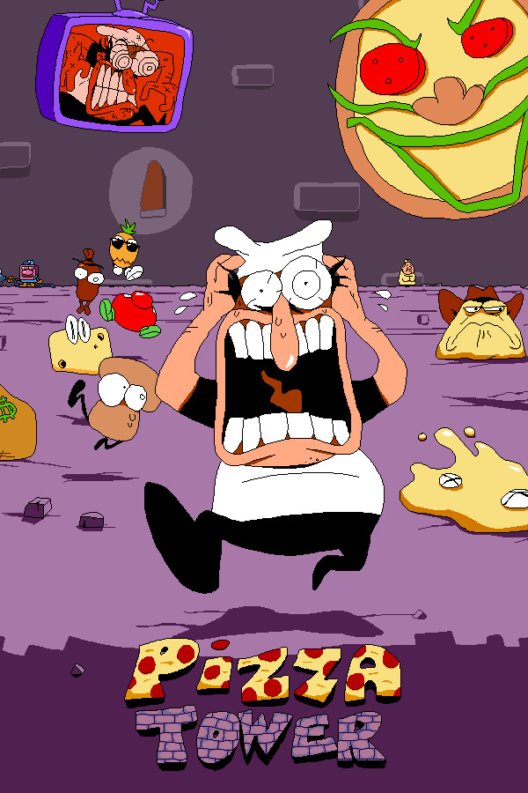

Pizza Tower - Goofy comedy sound effects. Vocal sample in night theme.

Plants vs. Zombies - Night theme and enemy hurt sounds.

Turnup boy commits tax evasion - Tone of music and sound effects.

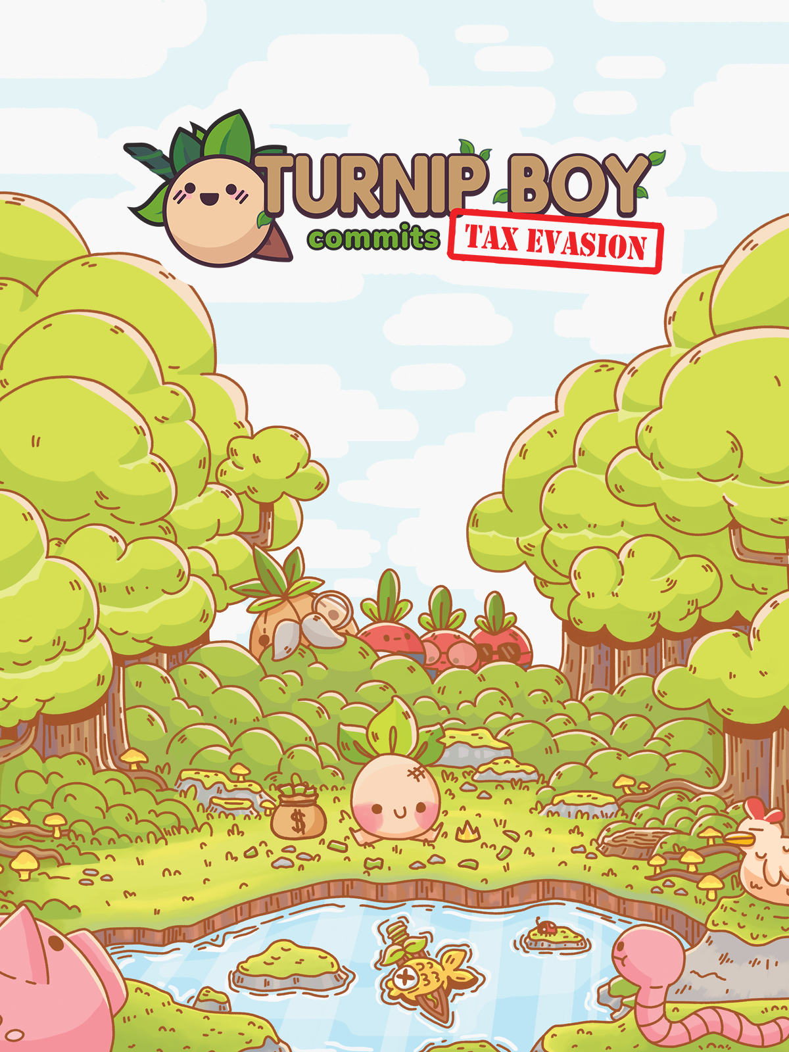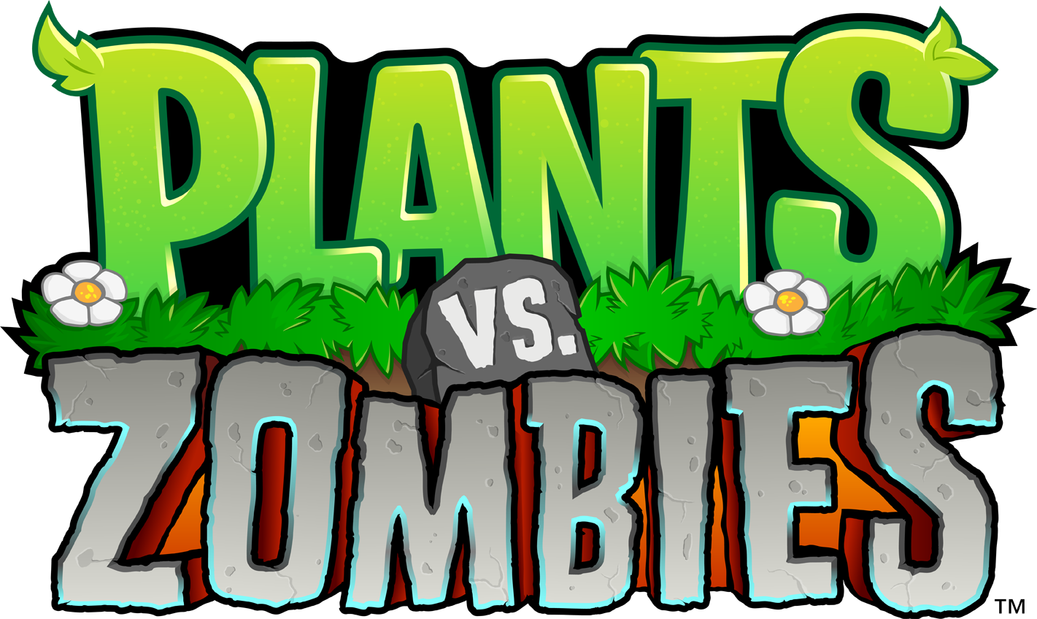

**Themes and Tone:**

Music and sound effects aim to have a comedic lighthearted tone. Slightly lo-fi retro quality overall mixed with high fidelity for impact and comedic effect. The juxtaposition of styles in sound effects used comically ie. dry real sounding gunshots from the cartoonish lime turrets, goofy enemy death sounds, etc.

Music is made using snes - ds era sample instruments and synths. Many sounds are sourced from super audio cart.

**Minimum Viable Product**

| **#** | **Task** | **Type** | **Status** |
| --- | --- | --- | --- |
| 1 | Design Doc | Misc | Finished |
| 2 | Player Controller | Coding | Finished |
| 3 | Tile system | Coding | Finished |
| 4 | Turrets | Coding | Finished |
| 5 | Day -> night transition | Coding | Finished |
| 6 | Night -> Day transition | Coding | Finished |
| 7 | Resource numbers | Coding | Finished |
| 8 | Enemy & their AI | Coding | Finished |
| 9 | Enemy Spawns | Coding | Finished |
| 10 | Tutorial room | Coding | Finished |
| 11 | Plants maturity | Coding | Finished |
| 12 | Victory Cutscene | Art | Finished |
| 13 | Defeat Cutscene | Art | Finished |
| 14 | Player Sprites | Art | Finished |
| 15 | Enemy Sprites | Art | Finished |
| 16 | Turret sprites | Art | Finished |
| 17 | Plant sprites | Art | Finished |
| 18 | Projectile Sprites | Art | Finished |
| 19 | UI | Art | Finished |
| 20 | Day music | Audio | Finished |
| 21 | Night music | Audio | Finished |
| 22 | SFX | Audio | Finished |

**Optionals**

| **#** | **Task** | **Type** | **Status** |
| --- | --- | --- | --- |
| 1 | Credits scene | Misc | In Progress |
|  | Changing Backgrounds | Art | Not Started |
|  | Turret alts/ Upgrades | Coding | Not Started |
|  | Button spam speeds construction | Coding | Not Started |

